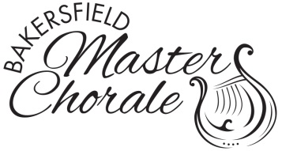

BAKERSFIELD MASTER CHORALE

*GREG SMITH MEMORIAL MUSIC SCHOLARSHIP*

APPLICATION

The scholarship is to provide assistance to individuals who are pursuing a Bachelors, Masters or Doctors degree in Music. Preference will be given to those nearing completion of his/her final year.

***Application deadline: April 12, 2019***

Personal Information

*Print Clearly*

Name: _____________________________________________________________________________

Address: ____________________________________________________________________________

City: ____________________________ State: ____________ Zip: ____________________________

Phone: _______________________________ e-mail: ______________________________________

I am pursuing a: _____ Bachelors Degree _____ Masters Degree _____ Doctors Degree

Area of Study: ____ Vocal/Instrumental Performance _____ Music Education _____ Composition

____ Musicology _____ Jazz Studies _____ Music Therapy

____ Other ___________________________________________________

I am attending, or have been accepted to (College or University):_____________________________________

(Graduate Students) From what College or University did you receive your Undergraduate Degree?_________

__________________________________________________________________________________________

Degree(s) previously earned: ___________________________________________________________________

1) Please include the following on a separate piece of paper:

* Your various school activities, especially those in music
* Honors and/or awards you have received
* Community activities including civic organizations, church, clubs, volunteer work, etc.
* Employment (FT/PT)
* Aspirations and goals for the future
* Description of Financial need.

2) Submit three letters of recommendation from faculty members, two of which must be from the Music department.

Letters of Recommendation must be on letterhead, dated, signed, and mailed directly to the address below by April 16, 2018.

**Mail application and recommendation letters to:**

**Scholarship Chairperson, Bakersfield Master Chorale, P.O. Box 1814, Bakersfield, CA 93303-1814**

**Direct inquiries for information to** [**info@bakersfieldmasterchorale.org**](mailto:info@bakersfieldmasterchorale.org)